Grand Plains Police Department

Date: 1/12/23
Subject: IOT Technology
To: Captain Goode
From: Andrew Koenig, Investigative Specialist
IOT devices are devices created to make your everyday life easier. Usually this is done by automating something and providing remote access to a device that would otherwise not need an internet connection. IOT devices have become a big part of our everyday lives in the last 5-10 years. Everything from your thermostat controlling the temperature of your house that you set on your phone, to your fridge being able to show you that you do in fact have plenty of milk while you’re in the dairy section of your local grocery store.
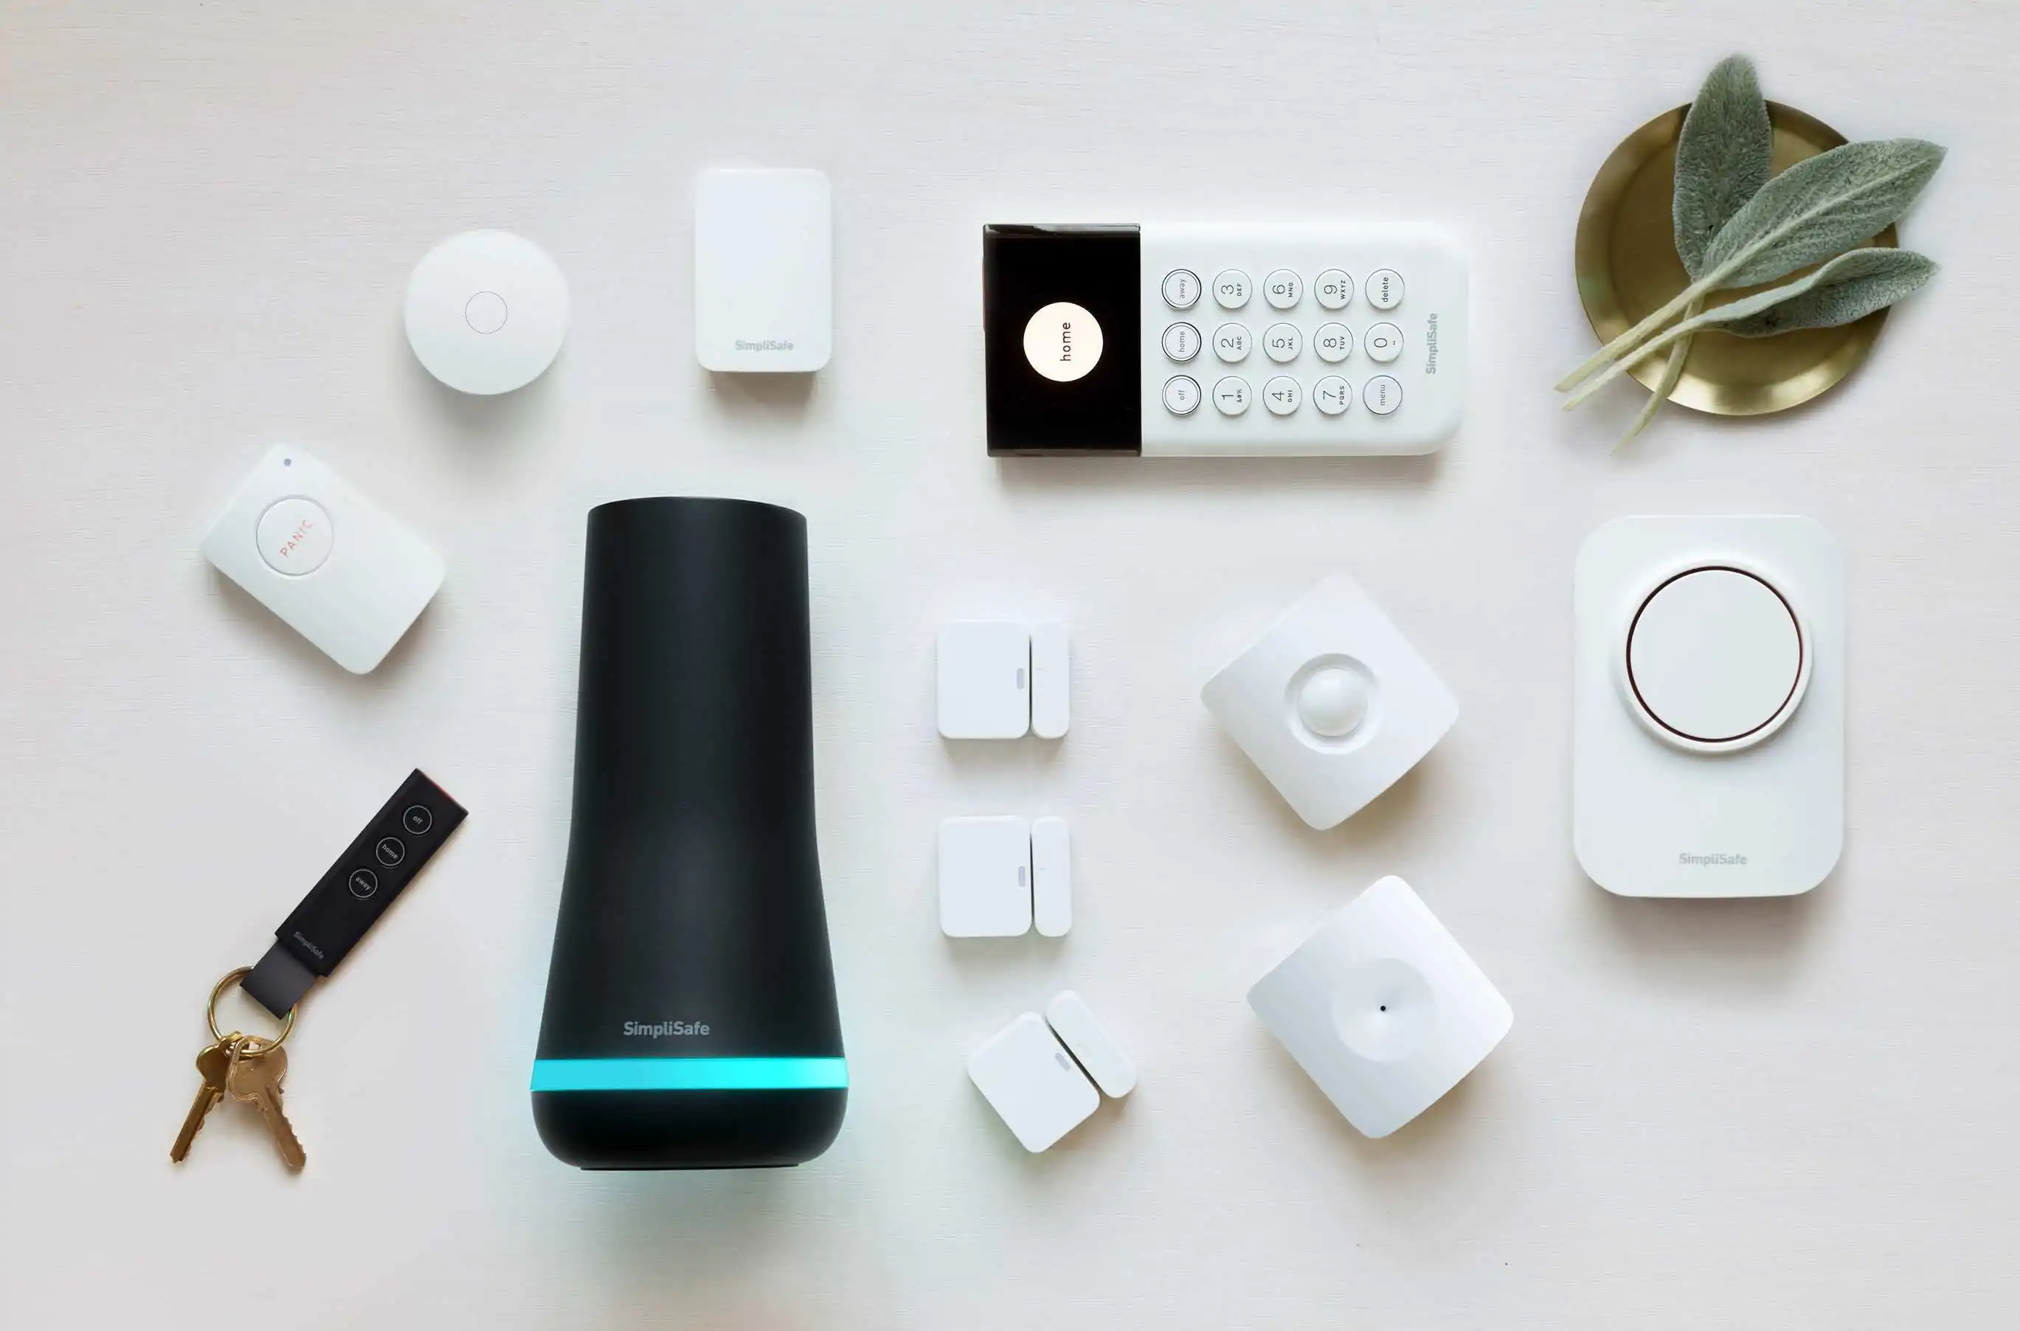
The wide variety of smart IOT devices that we have access to have made some of our daily tasks internet-reliant, and vulnerable. Every new device added to your home that has an internet connection is another way for an attacker to gain access to your network.
One example of these devices is home security systems such as SimpliSafe or Ring doorbells. These devices are meant to be easily set up and provide you with 24/7 surveillance over the area that you set them up. This allows a user to have a security system that they can monitor remotely over a wireless connection.
These home security systems have become increasingly popular in the last few years, and you can find many of them in homes today, you might even know someone with one. The problem with these systems is that while they can provide the intended user with an easy-to-use surveillance system, It can also be compromised by an attacker to gain valuable information about the owners or the property where the system is installed.
IOT devices are a problematic topic when considering law enforcement. These devices can allow law enforcement to gather more evidence of a crime through digital forensics, finding more out about where someone was at the time of the crime can be one example. They can also be a hindrance as it can also be a way for a criminal to dodge police more effectively with systems like SimpliSafe.
With how many different companies are making IOT devices these days, it’s important that you research the company you’re buying from. Too many companies have been found to be cutting corners when designing their devices, making them vulnerable, and therefore making your home network vulnerable. A system is only as safe as its weakest link.

Admin. “Why Ring Doorbell and Simplisafe Are Getting Hacked and How to Protect Your Home.” Barrier Security Systems LLC, 5 Oct. 2020, https://barriersecurity.net/why-ring-doorbell-and-simplisafe-are-getting-hacked-and-how-to-protect-your-home/.
Wroclawski, Daniel. “DIY Home Security Systems Vulnerable to Hacking.” Consumer Reports, 15 Feb. 2022, https://www.consumerreports.org/diy-home-security-systems/diy-home-security-systems-vulnerable-to-hacking-a7530099647/.

